PS C:\Users\anamika> get-disk

Number Friendly Name OperationalStatus Total Size Partiti

------ ------------- ----------------- ---------- -------

1 Virtual HD ATA Device Online 7 GB MBR

0 Virtual HD ATA Device Online 127 GB MBR

2 Microsoft Virtual Disk Online 1 TB GPT

3 Microsoft Virtual Disk Online 16 TB MBR

4 Microsoft Virtual Disk Online 1 TB RAW

PS C:\Users\anamika> initialize-disk 4

PS C:\Users\anamika> get-disk

Number Friendly Name OperationalStatus Total Size Partition Style

------ ------------- ----------------- ---------- ---------------

1 Virtual HD ATA Device Online 7 GB MBR

0 Virtual HD ATA Device Online 127 GB MBR

2 Microsoft Virtual Disk Online 1 TB GPT

3 Microsoft Virtual Disk Online 16 TB MBR

4 Microsoft Virtual Disk Online 1 TB GPT

PS C:\Users\anamika> new-partition -disknumber 4 -AssignDriveLetter -UseMaximumsize

Disk Number: 4

PartitionNumber DriveLetter Offset Size Type

--------------- ----------- ------ ---- ----

2 H 135266304 1023.87 GB Basic

PS C:\Users\anamika> get-partition

Disk Number: 1

PartitionNumber DriveLetter Offset Size Type

--------------- ----------- ------ ---- ----

1 D 65536 7 GB IFS

Disk Number: 0

PartitionNumber DriveLetter Offset Size Type

--------------- ----------- ------ ---- ----

1 1048576 500 MB IFS

2 C 525336576 126.51 GB IFS

Disk Number: 2

PartitionNumber DriveLetter Offset Size Type

--------------- ----------- ------ ---- ----

1 17408 128 MB Reserved

2 F 135266304 1023.87 GB Basic

Disk Number: 3

PartitionNumber DriveLetter Offset Size Type

--------------- ----------- ------ ---- ----

1 G 1048576 2 TB IFS

Disk Number: 4

PartitionNumber DriveLetter Offset Size Type

--------------- ----------- ------ ---- ----

1 17408 128 MB Reserved

2 H 135266304 1023.87 GB Basic

PS C:\Users\anamika> format-volume -DriveLetter H -FIlesystem NTFS

Confirm

Are you sure you want to perform this action?

Warning, all data on the volume will be lost!

[Y] Yes [A] Yes to All [N] No [L] No to All [S] Suspend [?] Help (default is "Y"): Y

DriveLetter FileSystemLabel FileSystem DriveType HealthStatus SizeRemaining Size

----------- --------------- ---------- --------- ------------ ------------- ----

H NTFS Fixed Healthy 1023.67 GB 1023.87 GB

PS C:\Users\anamika>

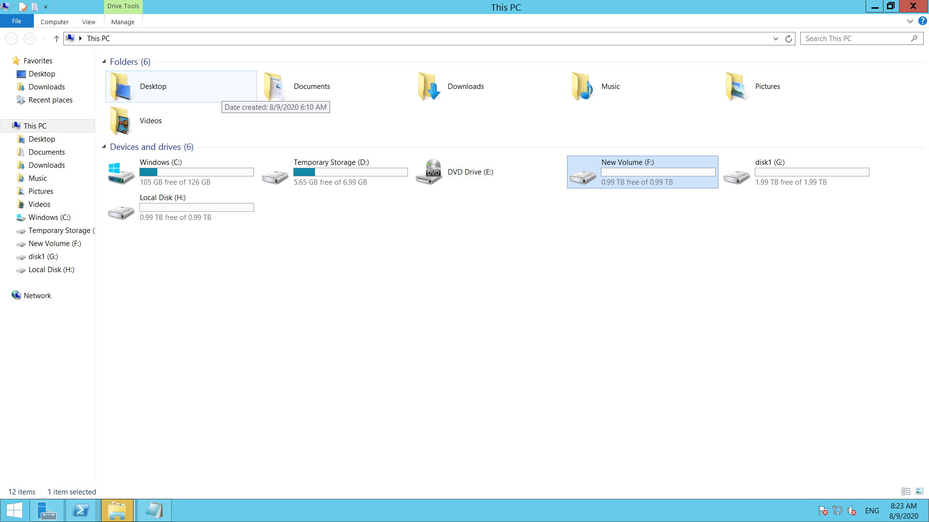

PS C:\Users\anamika> get-disk | where partitionstyle -eq raw | Initialize-disk 3 -partitionstyle mbr | new-partition -As

signDriveLetter -UseMaximumSize | format-volume -FIlesystem NTFS -NewFilesystemLabel "New disk" -confirm:$false

PS C:\Users\anamika>

<https://www.diskpart.com/articles/powershell-initialize-disk-7201.html>